

IMPROVING ACCESSIBILITY WITH LIMITED RESOURCES
June Isaacson Kailes MSW, Associate Director Christie Mac Donald MPP, Senior Policy Analyst Center for Disabilities Issues and the Health Professions Western University of Health Sciences 309 E. Second Street, Pomona, CA 91766 Voice-909.469.5213/TTY-909.469.5520, Fax 909.469.5503
ahcs@westernu.edu

Edition 2: 12.28.08

This brief is part of the Accessible Health Care Series available at www.cdihp.org/products.html#access_briefs
- Importance of Accessible Examination Tables, Chairs, and Weight Scales
- Review of Legal Research on Accessible Medical Equipment
- Health Care (Clinic / Out-patient) Facilities Access
- Choosing and Negotiating an Accessible Facility Location
- Providing Information in Alternative Formats
- Accessible Web-sites
- Improving Accessibility with Limited Resources
- Tax Incentives for Improving Accessibility
- ADA Resources
TABLE OF CONTENTS

1. INTRODUCTION

1. a. Complying with the ADA

1. b. Barrier Removal: A Continual Obligation
2. ACCESSIBILITY GUIDELINES
2. a. Priorities for Barrier Removal

3. CONDUCTING AN ON-SITE SURVEY
3. a. Entering and Exiting the Building
3. b. Path-of-Travel
3. c. Restroom Access
3. d. Effective Communication Signage
3. e. General Access
4. RESOURCES
4. a. Access Guidance Documents
4. b. Government Assistance
4. c. Communication and Customer Service Access
Disclaimer: The Center for Disabilities Issues and the Health Professions does not endorse nor profit in whole nor in part, from any manufacturer or vendor whose equipment appears in this publication. Illustrations of specific equipment are provided for information and educational purposes only.

1. INTRODUCTION

1. a. Complying with the ADA
The major pieces of federal legislation governing equal access to health care services for individuals with disabilities are the Rehabilitation Act (Rehab Act) and the Americans with Disabilities Act (ADA). These laws constitute a national mandate prohibiting discrimination based on disability in the provision of goods and services available to the public.
Section 504 of the Rehab Act prohibits any organization that receives federal financial assistance from denying individuals with disabilities equal access to the services. For example, hospitals, clinics, and other health care facilities that accept Medicaid, Medicare, or any other form of federal funding must comply with the Rehab Act. Section 504 states, “No otherwise qualified individual with a disability . . . shall, solely by reason of her or his disability, be excluded from the participation in, be denied the benefits of, or be subjected to discrimination under any program or activity receiving federal financial assistance.” If the provider serves just one Medicare or Medicaid beneficiary, that provider’s entire operations must comply with the Rehab Act. Medicare and Medicaid managed care plans must provide programmatic access to all its enrollees with disabilities.

ADA’s Title II extends the Rehab Act’s requirements to all state and local government activities. All health care providers who offer health care services, either directly or through contractual arrangements, to Medicare or Medicaid beneficiaries must comply with the Rehab Act because Medicare and Medicaid funding is considered federal financial assistance.

ADA’s Title III states: “No individual shall be discriminated against on the basis of disability in the full and equal enjoyment of the goods, services, facilities, privileges advantages, or accommodations of any place of public accommodation by any person who owns, leases (or leases to), or operates a place of public accommodation.”
All health care providers, including hospitals, nursing homes, psychiatric and psychological services, private physicians’ offices, diagnostic centers, physical therapy centers, and health clinics, are places of public accommodations and therefore must comply with Title III.

1. b. Barrier Removal: A Continuing Obligation
The ADA requires companies providing goods and services to the public to take certain limited steps to improve access to existing places of business. This mandate includes the obligation to “remove barriers from existing buildings when it is readily achievable to do so.” Readily achievable means, “easily accomplishable and able to be carried out without much difficulty or expense.”

The ADA establishes different requirements for existing facilities and new construction. However, while it is not possible for many existing small businesses to make their facilities fully accessible, much can be done without difficulty or expense to improve accessibility.

Readily achievable barrier removal is a continuing obligation. Barrier removal that was not readily achievable initially may later be required because more resources available. Therefore, you must continually monitor your facilities accessibility as well as your financial and other resources and engage in barrier removal as new measures become readily achievable. It is also important to remember that when you move to new facilities accessibility features of the new location need to be a very high priority.

Determining if a barrier removal is “readily achievable” is, determined on a case-by-case basis. The "readily achievable" requirement is based on the size and resources of the business. Barrier removal is an ongoing obligation -- you are expected to remove barriers in the future as resources become available.

2. ACCESSIBILITY GUIDELINES
The Americans with Disabilities Act Accessibility Guidelines (ADAAG) issued by the Access Board can serve as a guide for identifying the various kinds of measures that can be taken to remove barriers and as a guide for how best to remove them.

2. a. Priorities for Barrier Removal
When funds are not available to remove all existing barriers, the Department of Justice (DOJ) recommends an order of priorities for barrier removal:

1. Provide access from public transportation, parking areas, sidewalks, and entrances to the public accommodation so a person with a disability can “get through the door,” (e.g., installing an entrance ramp, widening entrances, and providing accessible parking spaces).

2. Provide access to those areas where goods and services are provided (e.g., adjusting the layout of display racks, clearing routes to exam rooms, rearranging tables, providing Braille and raised character signage, widening doors, providing visual alarms, and installing ramps).

3. Provide access to rest room facilities when they are open to the public (e.g., removal of obstructing furniture or vending machines, widening of doors, installing of ramps, providing accessible signage, widening of toilet stalls, and installation of grab bars).

4. Take other measures to provide access to goods, services, or facilities.

3. CONDUCTING AN ON-SITE SURVEY

It is helpful to conduct physical access surveys with people with disabilities who have a user’s perspective and who are knowledgeable about cross-disability access issues. Surveying demands strict attention to detail. Items that may seem minor to a person without a disability can really be major. A perceived minor detail can make a person’s ability to use a facility inconvenient or impossible. (See page 13 for a listing of survey tool resources)

Examples of low-cost barrier removal and/or modifications includes, but not limited to:

- Entrance and exit (see pages 5-7)
- Installing:
  - Portables ramps for access into/out of the building,
  - Low-energy door operators,
  - Off-set door hinges, and
  - Lever door handles.

- Path-of-travel (see pages 8-10)
- Ensuring:
  - 32” wide clear route (e.g. rearranging furniture, re-locating tables, chairs, trash receptacles, and potted plants),
  - Wheelchair turning radius,
  - Protruding objects, and
  - Patient reception desks too high and/ or access is blocked to lowered area of reception desk.

- Restroom Access (see pages 11-12)
- Insulating lavatory pipes under sinks,
- Repositioning a soap and/or paper towel dispenser to be in reach range,
- Installing a full-length mirror and grab bars, and
- Re-arranging toilet partitions to increase maneuvering space.

- Effective Communication signage (page 13)
- Pictorial symbol sign, braille and raised lettering

- General Access (see pages 13-14)
- Reachable placement of:
  - Pamphlets and brochures, and
  - Disposable water cups.

3. a. Entering and Exiting the Building

- Portables ramps

If there are steps up to the entrance, ramping one step or even several steps may be readily achievable.

If a public accommodation cannot meet the ADAAG's technical requirements for ramps because of space or other limitations, it can deviate slightly from these specifications as long as the ramp is still safe. If a permanent ramp cannot be installed, you can provide a portable ramp if readily achievable. Portable, i.e. moveable ramps must also be safe. Most portable ramps are inexpensive to purchase or construct.

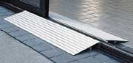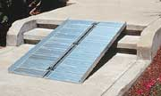
Figure 2: Temporary ramp provides rolling surface over two small steps
Figure 1: Temporary threshold ramp Temporary ramp to provides rolling surface over door threshold openings
If you use a portable ramp you should install a doorbell (with an appropriate sign) to call for an employee to bring the ramp to the door, if readily achievable. If the accessible entrance is one other than the main entrance, a sign at the main entrance should indicate where the accessible entrance is located.

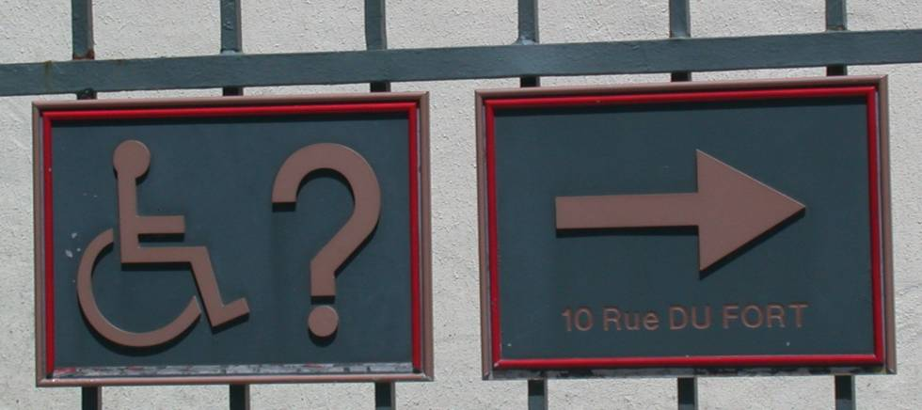

Figure 3: Direction signage indicating accessible entrance pointing to the right side of the building.

- Low-energy door operators
Low-energy door operators can provide a cost-effective solution that meets the intent of barrier-free code requirements. Installation of a low-energy operator on a restroom door can reduce the need for expanded approach and clear space dimensions.

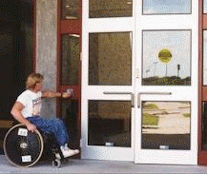
Figure 4: Automatic door opener, with large push button.
Figure 5: Automatic door opener, with large push button affixed to left of sliding doors.

- Hardware: off-set (continuous) door hinges

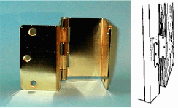
.
Off-set door hinges can add 2" to any doorway. Replacing existing hinges on doors with swing-clear hinges can often provide the necessary width (32 inches) for a wheelchair user to pass through.

Figure 6: Off-set door hinges.

Hardware: Door Knobs
Inaccessible door hardware can prevent access to the medical offices. For example, the handle shown (Figure 7 & 8) requires the user to tightly grasp the handle to open the door. People with limitations in grasping, such as arthritis, find this type of handle difficult or impossible to use.

- Non-accessible door hardware such as a thumb latch or a round door knob requires tight grasping, pinching and twisting to operate.

Tip: Close-fist test, try opening the door or operating the control using only one hand, held in a fist; if you can, than the door is usable by a broad range of people. The same is true for faucets, handles, drawer pulls, and vending machine controls.

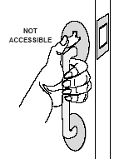
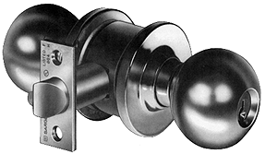

Figure 7: A thumb latch

Figure 8: A round door knob

- Accessible door handles such as lever (Figure 9) or loop hardware (Figure 10) can be used without grasping can be used without grasping, pinching or twisting.

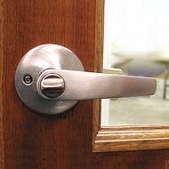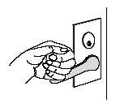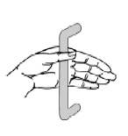
Figure 10: Loop-type handle

Figure 9: Lever handle

3. b. Path-of-Travel
Clear (path-of-travel) floor space: In addition to an accessible entrance, evaluate how people with disabilities will get into and around lobby, reception areas, and exam rooms.
- Wheelchair Turning Radius (turning space needed) For more information, See Access Board, ADAAG Standards, www.access-board.gov/adaag/html/figures (Turning Radius)
Turning radius: The T-shape space is 36 inches (915 mm) wide at the top and stem within a 60 inch by 60 inch (1525 mm by 1525 mm) square.
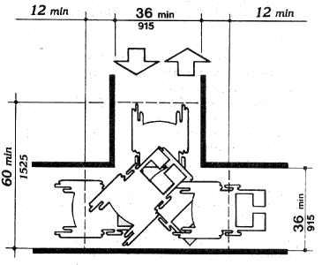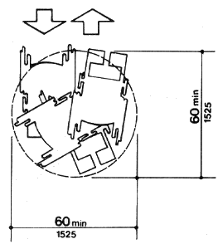
Figure 12: Space 60 in. Diameter

Figure 11: T-Shaped Space for 180 Degree Turns

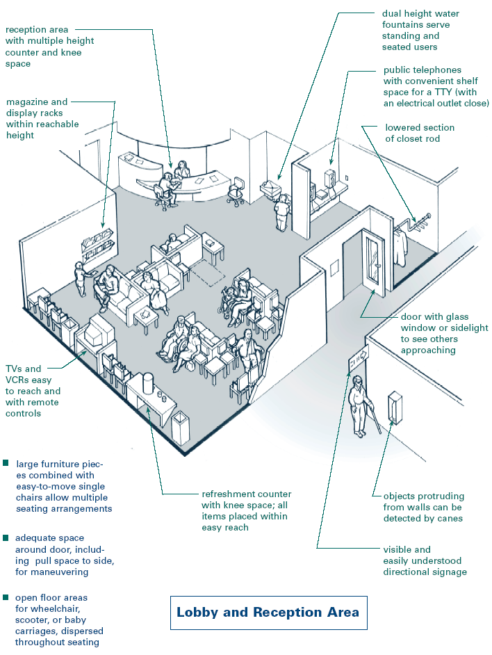

Figure 13: Detailed diagram of an accessible reception and lobby area, which includes lower reception areas, reachable magazine racks, dual height water sources, open areas for wheelchair users and scooters.^{xiv}

- Protruding objects

Patients with low or no vision may not be able to detect protruding objects on walls i.e. the chart boxed and shelves, which protrude over the 4” inch limit, and wheelchair users may hit their head.

Objects projecting from walls (for example, telephones) with their leading edges between 27 in and 80 in (685 mm and 2030 mm) above the finished floor shall protrude no more than 4 in (100 mm) into walks, halls, corridors, passageways, or aisles.^{xv}

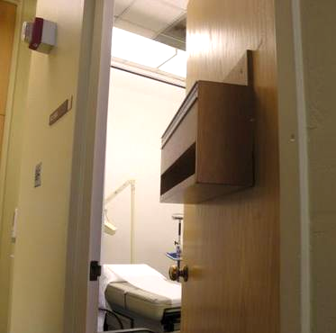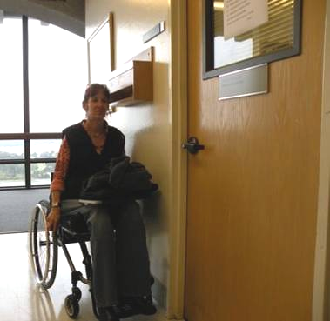
Figure 14: Chart box affixed to an examination entrance door, which protrudes over 4 inches.

Figure 15: Chart box affixed to an examination entrance door, shown as eye level to a wheelchair or scooter user.

- Patient reception desks too high and / or access is blocked to lower reception desk

Patient service counters may be too high for many users (see Figure 16 below), including people of short stature and wheelchairs users.

If service counters are too high, step around counters to speak directly to individual and provide service, and keep a clipboard or other portable writing surface handy for people unable to reach or use the counter when signing documents.

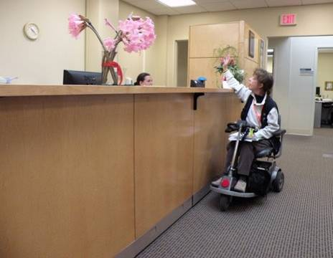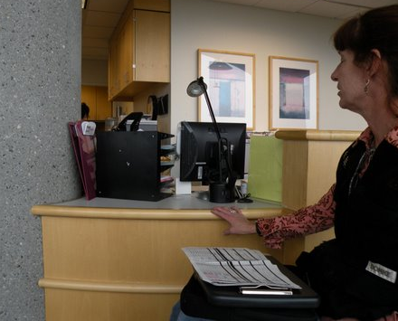
Figure 16: Reception desks too high for scooter user.

Figure 17: Computers and miscellaneous items block access to lower reception desk.
7

Access may be also blocked by computer monitors and miscellaneous items at lower sections of reception desks where scooter, wheelchair users, and people of short stature could easily communicate with staff.

- Educate staff on importance of keeping lower sections of reception desks clear and usable. (see Figure 18 below)

Figure 18: Patient using a scooter accessing a telephone located on a lower reception desk.
3. c. Restroom Access^{xvi}

Most of the requirements for accessible restrooms address making the interior of the restroom usable:
- One stall must be accessible,
- It must have sufficient room for a person in a wheelchair to enter, close the door, and
- Maneuver from wheelchair to toilet seat.

Possible solutions include:
- Reconfigure rest room, and/or
- Combine rest rooms to create one unisex accessible rest room.

Readily achievable elements in an accessible restroom include installing usable door hardware, grab bars in toilet stalls, re-arranging toilet partitions to create maneuvering space, insulating lavatory pipes under sinks to prevent burns, installing a full-length bathroom mirror, and repositioning the paper towel dispenser.

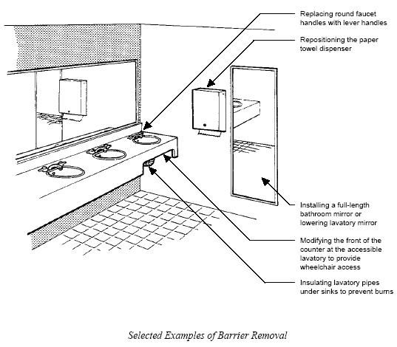

Figure 19: Detailed diagram of a restroom, which includes, leaver water handles, repositioning paper towel racks, installing full-length mirrors, and insulating lavatory pipes to prevent burns.^{xvii}
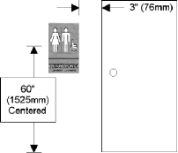
3. d. Effective Communication Signage
Figure 20: (left) Diagram detailing required height of accessible signage. Accessible signs should contain tactile lettering and Braille and be located 60 inches from ground and 3 inches from edge of a door. ^{xviii}

3. e. General Access

Other hardware and miscellaneous items can prevent access to the medical offices. The following are examples of low-cost solutions to improve access to brochures, and disposable water cups.

- Reachable pamphlets and brochures: A low-cost solution to inaccessible display racks is the use of desktop display holders. (Figure 22 below right)

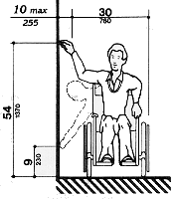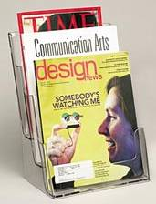
Figure 21: Diagram of accessible reach ranges for wheelchair and scooter users.^{xix}

- Disposable water cups: If your facility does not have an accessible water fountain, consider placing disposable cups next to the water fountain.


Figure 22: Disposable water cups can be placed within a reachable range near water fountains and coolers.

4. RESOURCES

4. a. ACCESS GUIDANCE DOCUMENTS

- Checklist for Readily Achievable Barrier Removal

Easy-to-use survey tool for identifying barriers in facilities. The complete checklists and worksheets are the kind of documentation that organizations should keep on file to demonstrate they are making good faith efforts to comply with the requirements of the ADA.
www.usdoj.gov/crt/ada/checkweb.htm

- Kailes, J., Americans with Disabilities Act Compliance Guide for Organizations,1995, (Hardcover)

Informal presentation on ADA compliance with chapters on: program access and nondiscrimination; physical access; communication access; and employment practices. Gives steps for completing an ADA compliance plan, contains checklists, planning sheets, samples of ADA compliance plans and lists many resources available for additional information and assistance. (Compliance with the transportation provisions of ADA is not covered).
www.jik.com/adacg.html

Contact June Isaacson Kailes, Disability Policy Consultant
Email: jik@pacbell.net, www.jik.com

- Removing Barriers to Health Care: A Guide for Health Professionals, 1998.

This booklet provides guidelines and recommendations to help health care professionals ensure equal use of the facility and services by all their patients. This guide gives health care providers a better understanding of how to improve both the physical environment and personal interactions with patients with disabilities
www.fpg.unc.edu/~ncodh/rbar/

PDF (335KB): www.fpg.unc.edu/~ncodh/pdfs/rbhealthcare.pdf

4. b. GOVERNMENT ADA PUBLICATIONS and INFORMATION

- ADA BUSINESS CONNECTION

- U.S. Small Business Administration Office of Entrepreneurial Development, U.S. Department of Justice Civil Rights Division

Americans with Disabilities Act (ADA) Guide for Small Businesses, October 15, 2002 www.sbaonline.sba.gov/ada/smbusgd.html

PDF (835 KB) www.sbaonline.sba.gov/ada/smbusgd.pdf

This 15-page illustrated guide presents an overview of some basic ADA requirements for small businesses that provide goods and services to the public. It provides guidance on how to make their services accessible and how tax credits and deductions may be used to offset specific costs.
- Reaching Out to Customers with Disabilities An online ADA course for businesses

A 10-lesson course divided it into individual lesson modules. Modules allow you and your staff to learn at their own pace. Topics include:
- Policies & Procedures
- Customer Communications
- Accessible Design
- Removing Barriers
- Alternative Access
- Maintaining Accessibility
- Transporting Customer
- Cost Issues
- ADA Enforcement
- Information Sources

- Ten Small Business Mistakes (video)

is thirteen-minute video identifies common mistakes that small businesses make when trying to comply with the ADA and addresses the importance and value of doing business with 50 million people with disabilities. www.ada.gov/videogallery.htm#anchor10mistakes990

Available modes:
- Dial Up (Modem & ISDN) and High Speed Internet (DSL/Cable)
- Quick Time | RealPlayer
- Open Captions | Audio Description

- THE ACCESS BOARD

1331 F Street, NW, Suite 1000
Washington, DC 20004-1111
Phone: 202.272.5434 (Voice) 202.272.5449 (TTY) 202.272.5447 (Fax)
Email: info@access-board.gov., www.access-board.gov

The following Access Board sites provide information about the Americans with Disabilities Act Accessibility Guidelines (ADAAG):

- ADAAG (Americans with Disabilities Act Accessibility Guidelines)
www.access-board.gov/ada-aba

- ADAAG Facility Access Surveys
www.access-board.gov/adaag/checklist/a16.html

- ADAAG Technical Assistance
Email: ta@access-board.gov
Phone: (800) 872-2253 (v)
(800) 993-2822 (TTY)
Fax: (202) 272-0081

- ADA Information Line (DOJ)
800.514.0301 Voice/800.514.0383 TTY www.usdoj.gov/crt/ada/infoline.htm

Toll-free ADA Information Line provides information and free publications about the requirements of the ADA including the ADA Standards for Accessible Design.
Title II (State and Local Governments)
Title III (Public Accommodations)
Public Access Section, Civil Rights Division, U.S. Department of Justice P.O. Box 66738 Washington, DC 20035-9998
1 (800) 514-0301; 1 (800) 514-0383 TTY
- Disability and Business Technical Assistance Centers (DBTACs)
Phone: 800.949.4232 (V/TTY) www.adata.org/dbtac.html

Regional centers to providing information, training, and technical assistance to employers, people with disabilities, and other entities with responsibilities under the ADA.

4. c. COMMUNICATION and CUSTOMER SERVICE ACCESS

- Kailes, J., Language is More Than a Trivial Concern! November 1990, Revised 1999.

Sensitizes people to appropriate terminology to use when speaking with, writing about or referring to people with disabilities. Challenges readers to be aware of the importance of using disability-neutral terms. Details preferred language and gives reasons for the disability community's preferences. Serves as an excellent reference tool for the public, media, marketers, providers and for board members, staff and volunteers of disability-related organizations. Includes a language quiz and many examples.

www.jik.com

- Kailes, J., Preferred Practices to Keep in Mind as You Encounter People Who Have Disabilities, Revised October 2000.

Describes practical approaches to use when serving or waiting on customers with physical, visual, hearing, cognitive, intellectual, and psychiatric disabilities, as well as people with significant allergies, asthma, multiple chemical sensitivities, and respiratory-related disabilities. Excellent training tool for people working with the public, includes a quiz as well as language and communication tips.

jik@pacbell.net,
www.jik.com/gpam.html

ENDNOTES
Title II applies to all public entities, defined as “any state or local government. 42 U.S.C. §12131 (2002). Section 504 applies to any entity that receives federal funding. 29 U.S.C. § 794. Federal financial assistance can be direct or indirect. Jacobson v. Delta Airlines, Inc., 742 F.2d 1202, 1211 (9th Cir. 1984).

^{i} Ibid.

^{ii} Ibid.

^{iV} Checklist for Existing Facilities version 2.1(revised August 1995), Adaptive Environments Center, Inc. for the National Institute on Disability and Rehabilitation Research. For technical assistance, call 1-800-949-4ADA (voice/TDD). www.usdoj.gov/crt/ada/racheck.pdf

^{V} Americans with Disabilities Act ADA Guide for Small Businesses (last revised - October 15, 2002). U.S. Small Business Administration Office of Entrepreneurial Development, U.S. Department of Justice Civil Rights Division. www.usdoj.gov/crt/ada/smbusgd.pdf
^{VI} Ibid.
^{VII} Ibid.
^{VIII} Kailes, J. (1994). Americans With Disabilities Act Compliance Guide For Non-Profit Organizations, Kailes-Publications, 6201 Ocean Front Walk, Suite 2, Playa del Rey, California 90293-7556, www.jik.com/resource.html, jik@pacbell.net.
^{IX} Check-list for Existing Facilities version 2.1
^{X} Kailes, J. (1994).
^{viii} Common Questions: Readily Achievable Barrier Removal. U.S. Department of Justice, Civil Rights Division, Disability Rights Section. ADA-TA, a series of technical assistance (TA) updates from the Disability Rights Section of the Civil Rights Division of the Department of Justice. www.usdoj.gov/crt/ada/adata1.pdf
^{ix} The Access Board, ADAAG Standards, www.access-board.gov/adaag/html/adaag.htm#4.8 (Section 4 Ramps)
^{x} Kailes, J. (1994).
^{xi} Americans with Disabilities Act ADA Guide for Small Businesses (last revised - October 15, 2002). U.S. Small Business Administration Office of Entrepreneurial Development, U.S. Department of Justice Civil Rights Division. www.usdoj.gov/crt/ada/smbusgd.pdf
^{xii} ibid.
^{xiii} ibid.
^{Xiv} Mace, FAIA, Ronald L., (1998), Center for Universal Design and The North Carolina Office on Disability and Health, Removing Barriers to Health Care: A Guide for Health Professionals.
^{xv} The Access Board, ADAAG Standards: www.access-board.gov
^{xvi} The Access Board, ADAAG Standards, restroom access: www.access-board.gov
^{xvii} Mace, FAIA, Ronald L.,
^{xviii} Common Questions: Readily Achievable Barrier Removal. U.S. Department of Justice, Civil Rights Division, Disability Rights Section. ADA-TA, a series of technical assistance (TA) updates from the Disability Rights Section of the Civil Rights Division of the Department of Justice. www.usdoj.gov/crt/ada/adata1.pdf
^{xix} The Access Board, ADAAG Standards: www.access-board.gov

Permission is granted to copy and distribute this material provided that:
- Proper copyright notice and citation is attached to each copy;

Required citation:

Kailes, J., and Mac Donald, C., Improving Accessibility with Limited Resources 2008. Published and distributed by the Center for Disability Issues and the Health Profession, Western University of Health Sciences, 309 E. Second Street, Pomona, CA 91766-1854, Voice-909.469.5213/TTY-909.469.5520, Fax 909.469.5503, email: ahcs@westernu.edu
- No alterations are made to the contents of the document.
- The document is not sold for profit.

